GreenFIE-HD:
Green Form-based Information Extraction for Historical Documents

Abstract
Many historical documents are rich in genealogical facts. Extracting these facts by hand, however, is tedious, and almost impossible considering the hundreds of thousands of genealogically rich family history books currently scanned and online. To make the extraction feasible, we propose to build GreenFIE-HD—a “Green” Form-based Information-Extraction tool for Historical Documents—“green” in the sense that it improves with use toward the goal of minimizing the cost of human labor while maintaining high extraction accuracy. Given a page in a historical document, the user’s task is to fill out given forms with all facts on a page in a document called for by the forms (e.g., to collect marriage information or all parent-child relationships stated on the page). GreenFIE-HD has a repository of patterns that it applies to fill in forms. A user checks the correctness of GreenFIE-HD’s form filling, adds any missed facts and fixes any mistakes. GreenFIE-HD learns based on user feedback, adding new patterns to its repository and adjusting existing patterns. Ideally, GreenFIE-HD improves as it proceeds so that it does most of the work correctly, leaving little for the user to do other than confirm that its extraction is correct. We will evaluate how well GreenFIE-HD performs on family history books in terms of “greenness,” i.e. how much human labor diminishes while maintaining high accuracy.

1. Introduction
The LDS Church has gathered, scanned, and OCRed thousands of books that contain rich genealogical information about people and events in their lives. To make the information in these books more readily searchable, there is a demand for extracting and indexing the many millions of basic genealogical facts contained in these historical documents. Both because of the volume of facts and the lack of structure of these facts, the Church’s current manual indexing program is insufficient for handling the task. In responding to the demand, we intend to build a “green” [Nagy12] annotation tool—one that improves with use toward the goal of minimizing the cost of human labor while maintaining high extraction accuracy. We call our tool GreenFIE-HD (Green Form-based Information Extraction for Historical Documents).
Figure 1 shows the intended user interface for GreenFIE-HD. A form to fill in is on the left and a page from a historical document is adjacent to it on the right. The system will work page by page, and we want to find all the information of interest as specified on the form before we move on to the next page. When the system initially loads a page for a form, it fills out the form as best it can using the information-extraction rules in its repository. A user can then check the filled-in form with respect to the document and either confirm that it is complete and correct or make changes to the form until it is complete and correct and then click on the “Submit Completed Work“ button. To allow the user to more easily check each record (collection of related facts for a form), GreenFIE-HD highlights the extracted information when the user hovers over a field of the form. Figure 1 shows the highlights when the hover arrow is over the first record. If the user sees that the system missed a record or records, the user can click the Add Record button to add empty records and fill them in by clicking on the text on the page to be placed in each of the fields of the record. If GreenFIE-HD added a record in error, the user can delete it by clicking on the red-box-X for the record. If a record is partially correct, the user can edit it. The Actions and Keyboard Shortcuts shown in Figure 1 provide the functionality needed for the user to check and correct filled-in form instances.
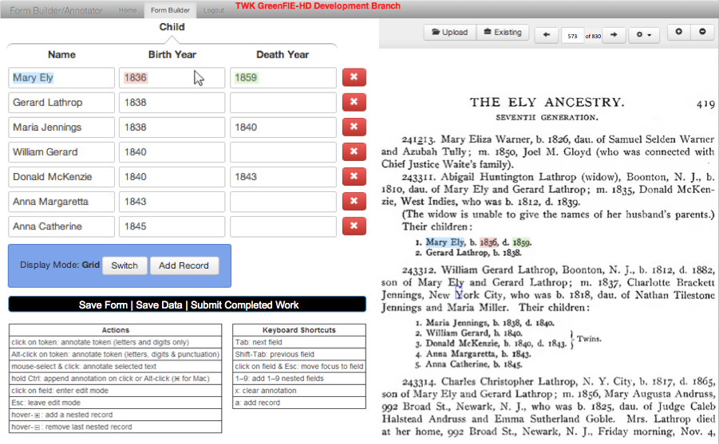
Figure 1. GreenFIE-HD User Interface.
There are two cases when the system learns from user input. First, when the system misses a record and the user adds one and fills it in, the system creates a new extraction rule for the new record and may merge it with an existing rule in the working repository. Learning also happens when the system fills in the form partially or entirely wrong and the user fixes it. The system will adjust the extraction rules or make a special exception so that it will not pick up the wrong information.
We will measure the effectiveness of GreenFIE-HD by measuring the amount of work and the time it takes to annotate pages with and without GreenFIE-HD. We will measure the “greenness” of the system by observing how many rules it creates and adjusts and how effective these rules and adjusted rules are in terms of precision and recall.
The contributions of this thesis will be in the construction of a GreenFIE-HD prototype whose new and interesting features are look-ahead automatic extraction, look-behind automatic extraction-rule creation and adjustment, and human-quality extraction accuracy.

2. Related Work
We are not aware of any other system like GreenFIE-HD—a system designed to allow users to annotate OCRed historical documents by filling in forms while at the same time synergistically working with users by learning from their annotation work and attempting to shift the burden of annotation as much as possible to itself, ideally leaving only the confirmation of annotation work as the only user task. We are, however, aware of work on various aspects of GreenFIE-HD: green systems that learn as users work, automatic information extraction, extraction-rule monitoring and revision, and annotation and other supporting tools.
Green Systems. Our research is about making tools that improve with use. Researchers have long been interested in these kinds of tools (e.g. see [BloN12]). Nagy is a strong proponent of these types of tools [Nagy12a]. In his recent keynote address at the Family History Technology Workshop [Nagy12b], he called a pattern recognition system “green” if it observes human effort to approve or correct the output of a learning system and then improves itself. We named our tool “green” in accordance with this idea.
Information Extraction. Our research falls in the general area of information extraction. Information extraction dates back to the early days of Natural Language Processing to recognize named entities such as people or organizations from natural language. It has been growing ever since and has become a field of its own [TuAC06]. In 2008, Sarawagi published a lengthy treatise summarizing the work and describing the various different information extraction problems researchers are interested in [Sara08]. At BYU, the Data Extraction Group has been active for over a decade (e.g. see [EmLL11] which summarizes much of their work). Information extraction continues to be an active area of research—a topic discussed in many international conferences and workshops (e.g. a recent tutorial at ICDE’13 [BaWY13] and a recent keynote address at ER’13 [Embl13]).
Extraction-Rule Monitoring and Revision. In our work we are building a “green” tool for information extraction that collects and revises extraction rules. Many others are trying to provide tools to investigate and revise extraction rules so that their systems can improve. Liu, et al. [LLC+10] suggest a ranked list of rule modifications to notify experts who wish to consider building greener tools. Sarma, Jain, and Srivastava [SaJS10] developed an approach that has three phases of investigation of rules for information extraction systems—explain the result, diagnose the influential and problematic component, and repair the output. We also revise the rules along the way so that they get better; however, we are not focused on the phases of investigation themselves, but rather in their practical application. We use ideas from this paper for managing our working set of extraction rules.
Existing Annotation and Supporting Tools. The prototype system we intend to build would be too large for an MS thesis project if we had to build it from the ground up. The main tools that already exist and on top of which we intend to implement GreenFIE-HD are the Annotator [DEG14] and OntoES [EmLL11]. We use the Annotator to build the GreenFIE interface and OntoES to apply rules that GreenFIE-HD creates. Since GreenFIE-HD can be adapted to make use of any kind of recognizers in the process of annotation, it does not matter how it receives patterns. Thus, it is possible to combine it with other pattern recognizers such as OntoSoar [LiLE13], ListReader [PacE13], and FROntIER[Park13] in future work.

3. Thesis Statement
GreenFIE-HD, whose features include look-ahead automatic extraction and look-behind pattern derivation and adjustment, can reduce annotation time for a user.

4. Project Description
4.1 Architecture
The proposed system will be composed of forms, books or sequences of pages, and a repository of extraction rules which will automatically fill in the forms and populate an ontology—a schema for the information of interest. Figure 2 shows the relationship among these GreenFIE-HD components. Figure 2 also shows two types of users: a knowledge engineer and an end user. A knowledge engineer will create forms for the end user to work with to specify the information to be extracted. End users will manage the extraction process, checking automatic system form-fill and editing results, as needed. 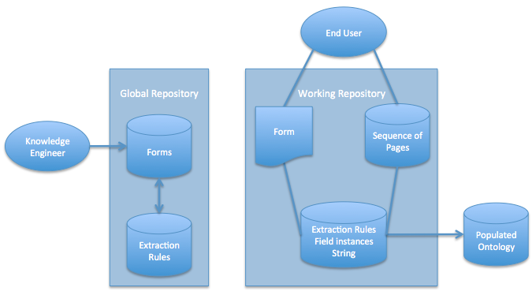
Figure 1. GreenFIE-HD System Architecture.
The global repository stores all the extraction rules GreenFIE-HD has encountered as the system processes the multitude of books in the collection. The working repository stores the extraction rules for the book GreenFIE-HD is currently processing. When the system starts a new book, it will run the extraction rules in the global repository and copy rules that find matches in the new book into the working repository. Once a book is finished, all the new extraction rules learned from the new book will be stored in the global repository. Unlike the global repository, the working repository stores not only extraction rules and their corresponding forms but also other information. Since the working repository has to provide all the information for filling the form and modifying the extraction rules, it stores field instances where the rules apply and the resulting strings from running the rules on the field instances.

4.2 Interface
The interface for the knowledge engineer is the BYU Annotator [DEG14]. (The Annotator exists already and is not part of GreenFIE-HD prototype development.) It allows the knowledge engineer to construct forms and ontologies—schemas for storing the extracted information. A form specifies the information wanted (e.g. the form in Figure 1 calls for a name, birth year, and death year of a person). For each form, the Annotator generates a mini-ontology (a conceptualization of the information specified). A collection of mini-ontologies derived from forms constitutes the ontology to be populated.
A user U interacts with the system through a selected form and a page in a selected book. The page can be a PDF document that has been OCRed or a plain text file, but is usually both: a PDF document superimposed over the OCRed plain text file. Thus, U works with what appears to be an image of the original page in a historical document, but is actually working with the plain text file that is mapped to the document image. Once the user chooses a form and a document to work with, GreenFIE-HD fills out the form for the page the best it can. When U hovers over a record, the system highlights each field and the corresponding text in the document. As Figure 1 shows, each field is highlighted with a different color for easy recognition. U then examines the record and goes on to the next if it is correct. If the record is incorrect, the user fixes the error using the manipulation operations specified in the Actions list in Figure 1. (The subsections below provide details about what GreenFIE-HD does in response to U’s edits.) If the whole record is wrong, U can click on the red-x button to delete it. When the form records are completely filled in correctly for the page, U clicks on the Submit Completed Work button (see Figure 1).

4.3 Extraction Rule Creation
Extraction rules for the GreenFIE-HD prototype are regular-expression rules as defined in FROntIER [Park13] and OntoES [EMLL11]. Initially, the working repository of extraction rules may be empty, or in any case, may not have a rule that recognizes a collection of data that should be extracted for the chosen form. In this case, U uses the provided form-filling actions (see Figure 1) to copy text from the document into the form fields of a record.
When U fills in a record, GreenFIE-HD creates a regular-expression extraction rule and puts it in the working repository. For example, when U annotates the highlighted record in Figure 3, GreenFIE creates the rule: \d{1}\.\s([A-Z][a-z]{2,6})\s([A-Z][a-z]{4,10}),\sb\.\s(\d{4}),\sd\.\s(\d{4})\. Observe that the capture groups in the regular expression precisely extract the information for each field and that the delimiter text precisely matches the text preceding and following each field.
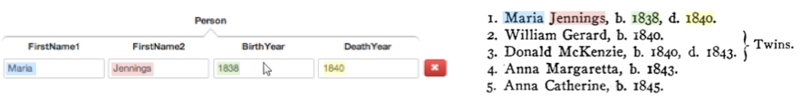
Figure 3. Record Annotation.

GreenFIE-HD uses the following transformations for turning a labeled text pattern into a regular-expression:
- Turn every sequence of n digits into “\d{n}”.
- Depending on capitalization, turn letter sequences into “[A-Z]{min, max}”, “[a-z]{min, max}, “[A-Z][a-z]{min, max}”, “[A-Z][A-Za-z]{min, max}”, or “[az][A-Za-z]{min, max}”—plus 30% of the length for the max and minus 30% for the min, and round up the min and the max.
- For delimiters between fields, use the text as it is.
- For delimiters before the first field and after the last field, include text up until the second white space or a line break.
These transformations may change as we learn more about rule initialization.
The set of rules can grow big fast. One way to manage the growth is to merge rules. For example, the only differences between the two records in Figure 4 are the length difference of FirstName1 and the field type difference of FirstName2. To merge, we can pick minimum and maximum of the FirstName1 expressions to be the new pattern’s minimum and maximum, and we can OR the expressions for FirstName2 (or observe that the second subsumes the first and just keep the second).
 |  |  | FirstName1 |  | FirstName2 |  |  |  |  |  | BirthYear |  |  |  |  |  | DeathYear
1 | . | _ | Maria | _ | Jennings | , | _ | b | . | _ | 1838 | , | _ | d | . | _ | 1840 | .
3 | . | _ | Donald | _ | McKenzie | , | _ | b | . | _ | 1840 | , | _ | d | . | _ | 1843 | .

 |  |  | FirstName1 |  | FirstName2 |  |  |  |  |  | BirthYear |  |  |  |  |  | DeathYear
\d{1} | \. | \s | ([A-Z][a-z]{2,6}) | \s | ([A-Z][a-z]{4,10}) | , | \s | b | \. | \s | (\d{4}) | , | \s | d | \. | \s | (\d{4}) | \.
\d{1} | \. | \s | ([A-Z][a-z]{3,7}) | \s | ([A-Z][A-Za-z]{4,10}) | , | \s | b | \. | \s | (\d{4}) | , | \s | d | \. | \s | (\d{4}) | \.

⬇
\d{1} | \. | \s | ([A-Z][a-z]{2,7}) | \s | ([A-Z][a-z]{4,10}|  [A-Z][A-Za-z]{4,10}) | , | \s | b | \. | \s | (\d{4}) | , | \s | d | \. | \s | (\d{4}) | \.

Figure 4. Extraction Rule Merge.

4.4 Recall Errors
Recall errors happen when a system fails to identify a record it should find or fails to extract one or more fields of a record it does find. For example, GreenFIE-HD might fail to fill in the DeathYear field for Robert in Figure 5. The rule “\d{1}\.\s([A-Z][a-z]{2,8})\s([A-Z][a-z]{1,8}),\sb\.\s(\d{4})\.” extracts the information shown. When the user fills in the missing field, GreenFIE-HD can create a new rule for the extraction and merge it with the rule that partially filled in the record, thus resulting in a new rule: “\d{1}\.\s([A-Z][a-z]{2,8})\s([A-Z][a-z]{1,8}),\sb\.\s(\d{4})\.(\nd\.\s\d{4})?”.
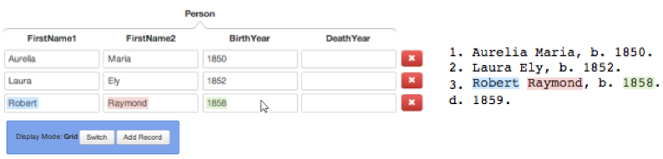
Figure 5. Example of a Missing Field Resulting in a Recall Error.
The system can sometimes miss a whole record. A rule that requires all digits for years, for example, would fail to match the birth year for Theodore in Figure 6 because of the OCR error where “1860” appears as “i860”. The user can click the Add Record button to add a blank record and then annotate the missing record. GreenFIE-HD can then generate a new regular expression and merge it (with an OR) or observe that it can just provide an alternative for the year: “\d{1}\.\s([A-Z][a-z]{2,8})\s([A-Z][a-z]{1,8}),\sb\.\s(\d{4}|i\d{3})(\.|,\sd\.\s(\d{4}))”.
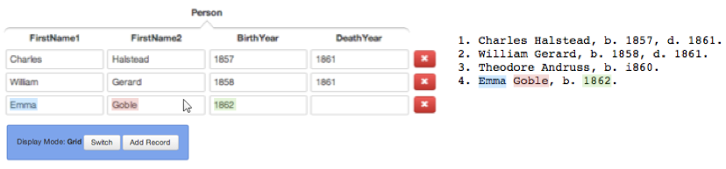
Figure 6. Example of a Missing Record Resulting in a Recall Error.

4.5 Precision Errors
The system can have precision errors, in which it can pick up incorrect information for a field or an entire record. In Figure 7, for example, it might pick up “Stillborn” as a part of the name when it should likely have been “Mary, Stillborn,” to denote that the parents gave the name “Mary” to their stillborn child. In this case, we can make a specific note to reject “Stillborn” as a part of a name. OntoES extraction rules makes this easy with its “Except” clause, which excludes results that would otherwise match a regular-expression extraction rule. 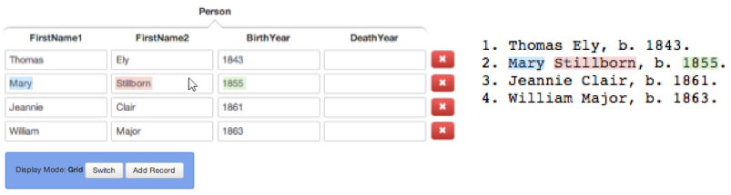
Figure 7. Example of an Incorrectly Filled-in Field Resulting in a Precision Error.
When a pattern is too simple, GreenFIE-HD can fill an entire record with the wrong information. For example, the pattern “\.\s([A-Z][a-z]{2,8})\s([A-Z][a-z]{1,8}),” matches “Home Journal” in Figure 8. Making the pattern more robust by looking for more context to the left and right side of the pattern can avoid this precision error. In this example, turning the pattern into “\d{1}\.\s ([A-Z][a-z]{2,8})\s([A-Z][a-z]{1,8}),\sb\.\s” will not match “Home Journal” but will match the other three names.
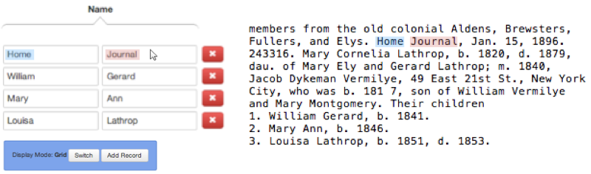
Figure 8. Example of an Incorrect Entire Record Resulting in a Precision Error.

5. Validation
Since there is no other tool that GreenFIE-HD directly competes with, we will not run an experimental evaluation against a competing tool. Instead, we will run field experiments to determine whether GreenFIE-HD reduces the time it takes to annotate historical documents. We plan to use three historical books that contain semi-structured genealogical information. Although it would be preferable to process entire books, because of time constraints, we will select a sequence of ten pages from each of the three books for processing. Since GreenFIE-HD is form-based, every 10-page sequence should have a lot of information that corresponds to the forms we plan to use. Participants in the experiment will annotate these pages with three different forms. One of the forms will be a simple form that includes a name sequence for a person together with birth/death date/place. A second form will be for marriages, including the bride and groom and the date and place of the marriage. The third form will be for parent-child relationships—the parents and a list of their children.
Half of the participants will be given the task of annotating with GreenFIE-HD first then annotating with just the Annotator itself. The other half will perform the task in the reverse order. This procedure should alleviate the effect of having an experience with one method or the other first.
The Annotator records and time-stamps all mouse and keyboard events. For the baseline, we will measure the time it takes for an individual to annotate with just the Annotator. For GreenFIE, we can determine the time it takes to check whether the system’s suggestions are right, the time for fixing recall errors, and the time for fixing precision errors. We can then obtain averages for various activities such as the time to check a record, the time to fix a recall error, and the time to fix a precision error. We will also count recall and precision errors and observe the trend as GreenFIE-HD learns. Factoring all of this information together, we should be able to report the relative advantage/disadvantage of using GreenFIE-HD compared to just the Annotator and report on the speed up as GreenFIE-HD learns and as users become more proficient at using GreenFIE-HD.
To validate the ‘greenness’ of the system, we will track and plot recall and precision errors as a function of the number of patterns created/merged. From this information we should be able to draw conclusions about the learning rates, about the variability in the semi-structuredness of the 10-page sequences, and about future work needed to improve Green-FIE-HD.

6. Thesis Schedule
- Implementation
  - Interface: upgrade current annotator, June – July 2014
  - Build the backend part of the system, July – October 2014
- Evaluation, October – Nevember 2014
- Write thesis document, December 2014
- Thesis defense, January 2015

Bibliography

[BloN12] D. Blostein and G. Nagy, Asymptotic Cost in Document Conversion, Proceedings of the 19th Conference on Document Recognition and Retrieval (DRR’12), San Francisco, California, USA, 24–26 January, 2012.

[BaWY13] D. Barbosa, H. Wang, and C. Yu, Shallow Information Extraction for the Knowledge Web, 29th International Conference on Data Engineering (ICDE’13), 1264–1267, April, 2013.

[LLC+10] B. Liu, L. Chiticariu, V. Chu, H. V. Jagadish, and F. R. Reiss, Automatic Rule Reﬁnement for Information Extraction, Proceedings of the VLDB Endowment (PVLDB), 588–597, September, 2010.

[Embl13] D. W. Embley, Keynote Address, Big Data—Conceptual Modeling to the Rescue, 32nd International Conference on Conceptual Modeling (ER’13), Hong Kong, China, November, 2013.

[EmLL11] D. W. Embley, S. W. Liddle, and D. W. Lonsdale, Conceptual Modeling Foundations for a Web of Knowledge, Chapter 15 in The Handbook of Conceptual Modeling: Theory, Practice, and Research Challenges, Springer, 477–516, 2011.

[DEG14] BYU Data Extraction Group, Annotator, http://dithers.cs.byu.edu/annotator2, 2014.

[LiLE13] P. Lindes, D. Lonsdale, D. Embley, OntoSoar: Using Language to Find Genealogy Facts, Family History Technology Workshop, Salt Lake City, Utah, March, 2013.

[Nagy12a] G. Nagy, Estimation, Learning, and Adaptation: Systems that Improve with Use, Proceedings of the Joint IAPR International Workshop on Structural, Syntactic, and Statistical Pattern Recognition, Hiroshima, Japan, 1–10, November, 2012.

[Nagy12b] G. Nagy, Keynote Address: Back to the Future, Family History Technology Workshop, Salt Lake City, Utah, February, 2012.

[PacE13] T. L. Packer and D. W. Embley, Cost Effective Ontology Population with Data from Lists in OCRed Historical Documents, Proceedings of the 2nd International Workshop on Historical Document Imaging and Processing (HIP’13), Washington D.C., 1–8, August, 2013.

[Park13] J. Park and D. W. Embley, Extracting and Organizing Facts of Interest from OCRed Historical Documents, Family History Technology Workshop, Salt Lake City, Utah, March, 2013.

[Sara08] Sunita Sarawagi, Information Extraction, Foundations and Trends in Databases, vol. 1 nr. 3, 261–377, March 2008.

[SaJS10] A. D. Sarma , A. Jain , D. Srivastava, I4E: Interactive Investigation of Iterative Information Extraction, Proceedings of the 2010 ACM SIGMOD International Conference on Management of Data, Indianapolis, Indiana, 795–806, June 6-10, 2010.

[TuAC06] J. Turmo, A. Ageno, and N. Catala. Adaptive Information Extraction, ACM Computing Surveys, 1–47, 2006.

